Homegrown TV DVD Catalog

The 2010 Free Flight Model Airplane Championships

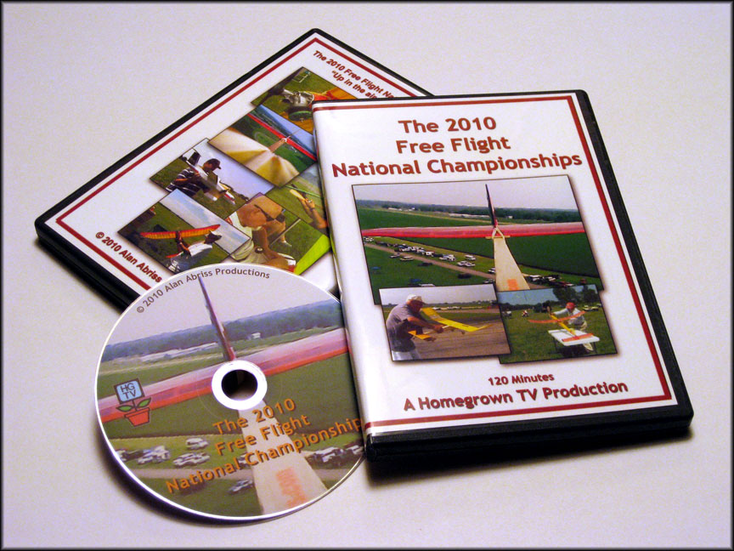

New for 2010, in flight point of view video shot from the wing of a free flight model in flight. Now you can experience what it would be like to ride on a model. Experience the thrill of a high speed launch, and the violent action of the DT and landing. After watching this you will gain new perspective on the punishment that a free flight model goes through during a flight. Also new for this year are the Flying Aces scale events. WWI and WWII mass launch events are also included. The 2010 Free Flight Model Airplane Championships continues to be the premier model airplane contest that every free flight model builder strives to win. Whether you fly free flight or just enjoy watching a model flying free with this DVD you will be able to see some of the action from the 2010 Nats. Watch Dakotas take to the air. The rise off water events include rubber powered models as well as gas. Arrive on the flying site at 6:00AM for the Dawn unlimited event. This DVD is a must for your collection.

120 Minutes DVD $20.00 + S&H
Top of Form
Bottom of Form

The 2009 Free Flight Model Airplane Championships

The 2009 Free Flight Model Airplane Championships continues to amaze year after year. This is the premier model airplane contest that every free flight model builder strives to win. Whether you fly free flight or just enjoy watching a model flying free with this DVD you will be able to see some of the action from this years Nats. Watch Dakotas take to the air, or crash. The rise off water events include rubber powered models as well as gas. Arrive on the flying site at 6:30AM for the Dawn unlimited event. . This DVD is a must for your collection.

119 Minutes DVD $20.00 + S&H

The 2008 Free Flight Nationals

The 2008 Free Flight Nats was one of the best yet. Despite fewer competitors, due to high gasoline prices, the weather was great (except Tuesday) and the flying was spectacular. If you did not attend the 2008 Nats due to the cost of gasoline then you'll be able to see some of the action you missed. The rise off water events include rubber powered models as well as gas. Electric events are also featured. Arrive on the flying site at 5:30AM for the Dawn unlimited event. Watch Dakotas take to the air, or crash. This DVD is a must for your collection.

119 Minutes DVD $20.00 + S&H

The 2007 Free Flight Nationals

The 2007 Free Flight Nationals is also the 40th Anniversary of the National Free Flight Society. We can't think of a better way to celebrate than to re-visit this years Nats with this video. See what the country's top model builders are flying. Interviews with various modelers showing close-ups of their airplanes. See the new discus launch gliders and Electric events. The ROW and Dawn Unlimited are also shown along with non-stop flying action. This a video not to be missed!

120 Minutes DVD $20.00 + S&H

The 2006 Free Flight Nationals

Spend a week walking the flight line at the 2006 Free Flight Nationals. See what the country's top model builders are flying. Interviews with various modelers showing close-ups of their airplanes. The ROW and Dawn Unlimited events along with non-stop flying action makes this a video not to be missed!

112 Minutes DVD $20.00 + S&H

The 2005 Free Flight Nationals

This 2005 Free Flight Nats documentary is the one free flight video you'll want to own more that any other. The 2005 contest brings back, after 25 years, the ROW (rise off water) event. Watch free flight models take off from the world's smallest pond. 2005 also brings back "Fast Richard" Mathis. Jim Bocckinfuso's 15 minute interview with this free flight legend is must see TV for every model builder! Also interviews with various modelers, the Dawn Unlimited event and non-stop flying action makes this a video not to be missed!

2 HOUR DVD $20.00 + S&H

The 2004 Free Flight Nationals

If you attended the 2004 Free Flight Nationals you'll want to revisit your trip. If you did not go to the Nats you'll want to see what you missed. 2 hours of non stop Free Flight action. Rubber power, gas power and hand launched gliders are seen taking to the air. See a 1/2A model being built in a hotel room on Thursday night then being flown on Friday morning to a first place finish, by a 12 year old flyer! All this and more. This one belongs in your collection.

2 HOUR DVD $20.00 + S&H

The 2003 Free Flight Nationals
This video celebrates the 100th anniversary of powered flight with a visit to Wilbur Wright's birth place. Included is a short tour of his house and museum. A demonstration of the Wright's wind tunnel is also included. Then travel forward in time to the 2003 Free Flight Nationals where you will be treated to non stop flying action. See footage of Gene Bowers flying his 97" Goldberg Zipper. Steve Perryman flying his Dad's Speckled Bird in the Dawn unlimited event is simply majestic. Close-ups of hand launch gliders in flight are a joy to behold. Plus much more! This video is a must for your collection.
117 minutes DVD $20.00 + S&H

A 2001 FREE FLIGHT ODYSSEY
The first Free Flight Nats of the new millennium. Pure flight for flight's sake. This video brings you the action and thrill of free flight model airplanes. Also a tour of the new AMA headquarters building, and a visit to the NFFS dinner and barbeque. Interviews with the flyers and officials make this video a must for every collection!
Please note this DVD was converted from S-VHS.
119 minutes DVD $20.00 + S&H

The 2000 FREE FLIGHT NATIONALS

The 2000 NFFS- AMA F/F NATS VIDEO.THIS IS THE BEST ONE YET! THE LAST FREE FLIGHT NATS OF THE CENTURY. IN ALMOST 100 YEARS FREE FLIGHT HAS REMAINED BASICALLY UNCHANGED. PURE FLIGHT FOR FLIGHT'S SAKE. THIS VIDEO BRINGS YOU THE ACTION AND THRILL OF FREE FLIGHT MODEL AIRPLANES. ALSO INCLUDED IS AN IN-DEPTH INTERVIEW WITH JIM WALSTON WHO DEMONSTRATES HIS MODEL RETRIEVAL SYSTEM. A MUST FOR EVERY COLLECTION!

118 minutes DVD $20.00 + S&H

THE 1999 FREE FLIGHT NATIONALS

The NFFS / AMA Nationals just keeps getting better every year. The 1999 contest was one of the best in recent history. This video has it all, from the destruction of one model at the start to the creation of many new ones at the end. AMA and National Free Flight Society events are featured in this 116 minute documentary. Spectacular aircraft footage and interviews with the flyers makes this a video not to be missed. Also on this video is a visit to Campbells Custom Kits, where Lee Campbell demonstrates his rib cutting technique! This is the perfect souvenir for all flyers who want to relive the weeks events. This video is a must for every free flight pilot’s collection!

115 Minute DVD $20.00 + S&H

THE 1992 AMA NATIONALS

The last unified Nationals, when every event was flown simultaneously on the same field for one week. This Nationals was held at Westover Air Force Base in Chicopee, Mass. This one has it all R/C, U/C, FREE FLIGHT OUTDOOR AND INDOOR. Taped during the week of the National Model Airplane Championships this 105 minute video features Navy Carrier, Control line Combat, Radio control Pylon Racing, Radio control Helicopters, Indoor and Outdoor Free flight plus other events. Each segment has interviews with the officials and the contestants to help fully explain all the events. Combined with music by The California Guitar Trio this is the perfect video to show to your non modeling friends and at mall shows.

Please note this DVD was converted from S-VHS.

1 Hour 45 Minute DVD $20.00 + S&H

BROOKLYN SKYSCRAPERS
A video history of one of the oldest model airplane clubs in the country. This documentary was assembled using old home movies from the clubs archives. This rare film footage of modeling activity from 1939 and 1957 is a must for any collectors video library. This rare footage is combined with new video showing today's members explaining the various events. The soundtrack, as varied as the modelers, goes from big band to rock and roll. This may be the first model aviation music video! Also included on the same DVD is video of the 1947 INTERNATS .
Please note this DVD was converted from S-VHS.
1 hour 20 minutes DVD $20.00 + S&H

SILENT MAGIC

This twenty minute DVD shows the world of indoor free flight. Written and narrated by Don Ross, this video is perfect for showing to school groups, at mall shows and to prospective flying site owners to show them what Indoor Model Aviation is all about. Footage of all types of indoor models are featured, from simple stick models to complex F1D's and highly detailed scale models. A MUST FOR YOUR COLLECTION!
Please note this DVD was converted from S-VHS.
20 minutes DVD $15.00 + S&H
To order:

MAIL CHECK OR MONEY ORDER TO:

ALAN ABRISS

94-20 66th Avenue Suite 1G

Forest Hills, N.Y. 11374

718-275-6362

Please call for shipping charges on multiple DVD orders.

